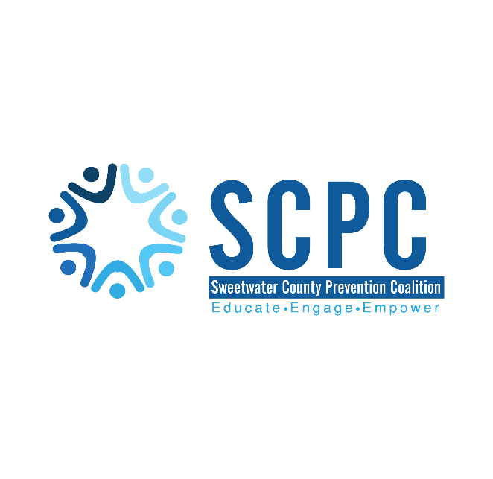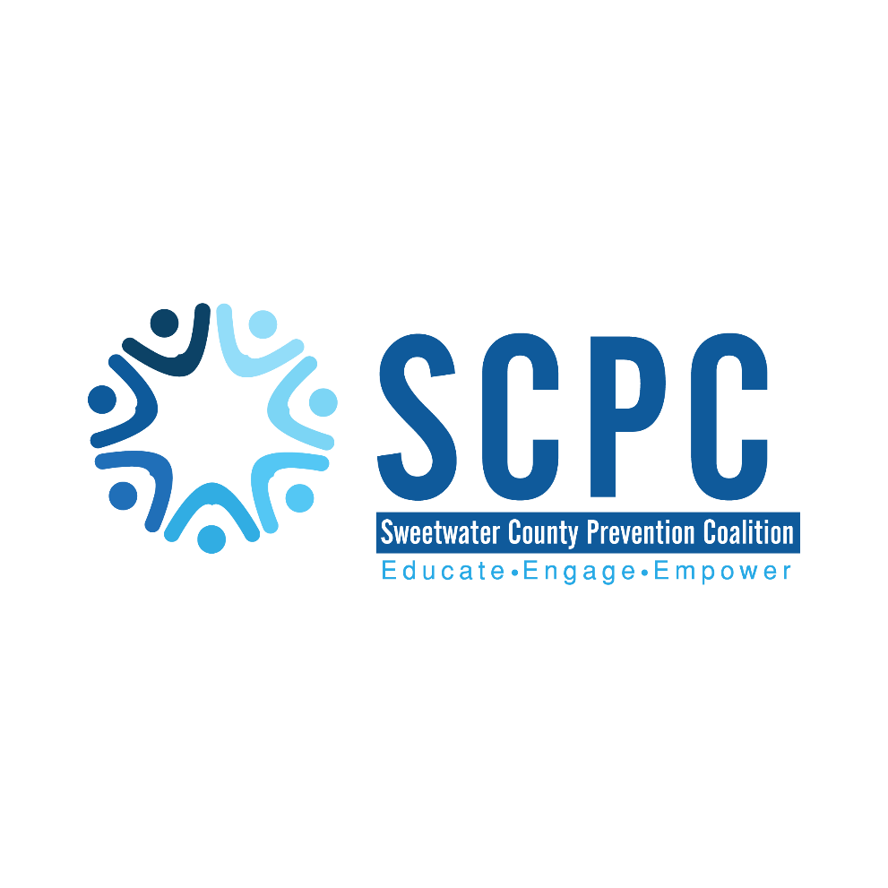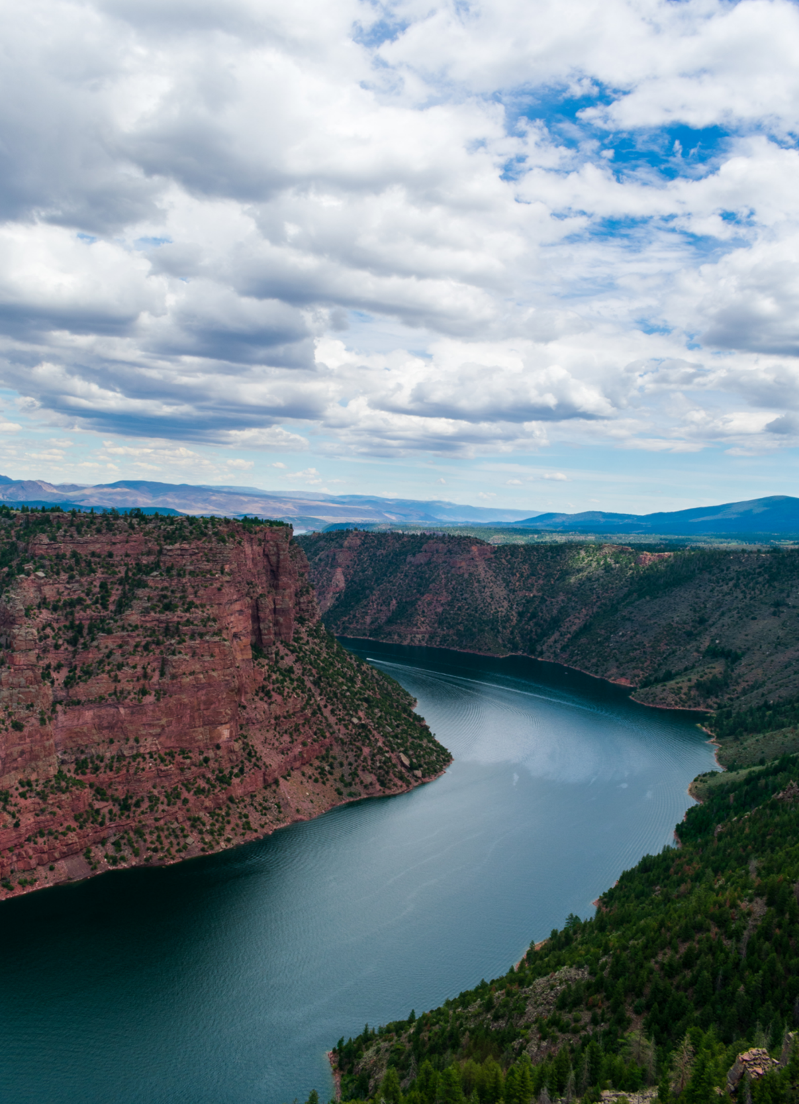

Developed By

**Sweetwater County**

**Mental Health**

**Resource List**

We would like to thank the members of the Sweetwater County Prevention Coalition for their diligent effort for helping us put this resource list together.

Updated September 19, 2024

Table of Contents

Table of Contents 3

Counseling and Mental Health 3

Support Groups 6

Sweetwater County Prevention Coalition 9

*Organizations with an asterisk are also youth serving organizations.

# Counseling and Mental Health

**National Lines:  
Suicide Prevention Lifeline**  
Support for people who are in a suicidal crisis or emotional distress. Provides prevention and crisis resources.

**988**

Available 24/7 – Confidential – Free   
1-800-273-8255 (TALK)   
**Spanish Speaking**  
1-888-628-9454  
Disponible 24/7 – Confidencial – Gratis  
**Deaf or Hard of Hearing**711 then 1-800-799-4889  
**Veterans**  
1-800-273-8255 and Press 1  
**Text Line**(307) 776-0610

**ImAlive Crisis Chatline**Live online instant messaging network for people in crisis available 24/7.  
Go to: imalive.org

**Crisis Text Line**Crisis intervention texting hotline available 24/7.  
Text HOME to 741-741

**The Trevor Project**Hotline, webchat, and text service available 24/7 for LGBTQ youth.  
**TrevorLifeline**  
1-866-488-7386  
**TrevorChat**  
thetrevorproject.org/get-help-now  
**TrevorText**  
Text “START” to 678-678

**Local Resources:  
Southwest Counseling Service\***Counseling for individuals, children, adolescents, and families. Groups for mental health, substance abuse, and psychosocial. Clinical assessments, outpatient, and inpatient services. Psychiatric, and medical services. Sober Living and Supported Independent Living Program. Youth summer program. Telehealth option.   
**Sliding fee scale, accepts Medicaid**  
  
Website: www.swcounseling.org  
**Local 24 Hour Crisis Line:  
307-352-6677**

**Mental Health Services**1124 College Dr.   
Rock Springs, WY 82901  
Phone: (307) 352-6680  
Hours:  
 Mon. & Wed. 8:00am – 8:00pm  
 Tue. & Thur. 8:00am – 6:00pm  
 Fri. 8:00 am – 1:00 pm

**Recovery & Billing Services**2300 Foothill Blvd.   
Rock Springs, WY 82901  
Phone: (307) 352-6677  
Hours:   
Mon. & Wed. 8:00am – 9:00pm  
Tue. & Thur. 8:00am – 7:00pm  
Fri. 8:00am – 7:30pm

**Medical & Psychosocial Services**2706 Ankeny Way  
Rock Springs, WY 82901  
Phone: (307) 352-6689  
Hours:  
Mon. - Thur. 8:00am – 5:00pm  
Fri. 8:00am – 12:00pm

**Rock Springs Community Health Center (Bear Lake Community Health)**  
Medical, Dental, Pharmacy, OB/GYN, Behavioral Health,   
Telehealth option.  
**Sliding fee scale, payment plans, accepts Medicaid.**  
  
2620 Commercial Way, Suite #140  
Rock Springs, WY 82901  
Phone**:** Clinic- (307) 212-5116 Pharmacy- (307) 212-5105  
Office HoursMonday-Friday: 8:00am – 6:00pm  
After-Hours Clinical Advice Services Available 24/7  
Pharmacy HoursMonday – Friday 8:00am – 6:30pm  
Lunch from 1:30pm – 2:00pm

Website:

www.bearlakecommunityhealthcenter.org

**Better Solutions Counseling**Individual, family, couples, art therapy and EMDR therapy. Psychological & psycho-educational services. Specializes in autism, physical, mental, or cognitive disabilities, crisis counseling, and general counseling.  
**Accepts Medicaid. Bills insurance.**

2001 Dewar Drive  
Suites 230 and 270  
Rock Springs, WY 82901  
Phone: (307) 382-3058

Website: www.bettersolutionscounseling.com

**High Point Counseling\***Individuals, couples, family, youth and adult counseling. Psychological testing. Addiction, trauma, and marriage counseling. Telehealth option.  
**Accepts Medicaid**

2632 Foothill Blvd. Suite 101  
Rock Springs, WY 82901  
Phone: (307) 212-8014  
Hours: Mon. – Thur. 9:00am – 5:00pm

Website: www.highpointcounseling.com

**Sweetwater Counseling\***  
Family and Trauma therapy. Cognitive behavioral therapy. EMDR therapy.  
Youth and adults.

1471 Dewar Drive Suite 214,   
Rock Springs, WY 82901  
Phone: (307) 389-4674  
Email: rtschroeder@me.com

Website:   
[www.sweetwatercounseling.com](http://www.sweetwatercounseling.com)

**Wellness Associates\***Individuals, couples, families. Mental health, eating disorders. Sport psychology, seminars. Nutrition, fitness, and weight management.  
**Takes Medicaid**

1471 Dewar Dr  
Rock Springs, WY 82901  
Phone: (307) 630-3466  
Hours: Appointments available Monday thru Saturday

Website: www.wacounseling.com

**WEvolve Counseling\***Therapy for self-harm, trauma and PTSD. Individuals and couples. Adults and adolescent. Telehealth offered.

1471 Dewar Drive #209   
Rock Springs, WY 82901  
Phone: (307) 352-9161  
Hours: Mon. – Fri. 8:30am – 5:30pm

Website:  
www.wevolve-counseling.com

**Access Balance & Change\***Treatment for adults, treatment for adolescents, evaluations. Individuals, couples, and family therapy.  
**Accepts Medicaid**

126 Elk St.  
Rock Springs, WY 82901  
Phone: (307) 382-6330  
Hours:  
Mon. – Thur. 9:00am – 6:00pm

Website: www.abcrocksprings.com

**Wellbeing & Accessibility\***Free counseling services for students at Western. Crisis services for students. Help with accommodations for students who need them. Relaxation room.

2500 College Dr., Room 1227  
Rock Springs WY, 82901  
Phone: (307)382-1652  
Hours: Mon. – Fri. 8:00am – 5:00pm

Website:  
www.westernwyoming.edu >  
Student Life Tab >  
Campus Amenities >  
Wellbeing & Accessibility

**Professional Counseling Services, LLC\***

Individual and family therapy. Therapy for trauma and PTSD. EMDR and Synergy Play Therapy certified. Children, adolescents, and adults. LGBTQIA2+

**Accepts Medicare**

50 Shoshone Ave STE B,

Green River, WY 82935

Phone: 307-337-9830

Hours: Tues--Thurs. 9:00am--5:00pm

Fri: 9:00am-1:00pm

Website: www.mindytollefson.com

**Mind Works Behavioral Health, LLC\***

Individuals, families, children, adolescents, and adult therapy. Person-centered and trauma focused. **Accepts Medicaid**

538 Pilot Butte Ave Suite 5,

Rock Springs, WY 82901

Phone: 307-228-5950

Hours: Mon – Thurs.

Website: www.mindworksbehavioralhealth.clientsecure.me

**Roots to Rise\***

Play therapy and counseling services. ART therapy. Children, adolescents, and adults.

408 S Main Street

Rock Springs, WY 82901

Phone: 307-374-4014

Website: www.roottoriseinc.com

# Support Groups

**National & Local  
Alcoholics Anonymous**Support for people experiencing alcoholism.District 8 Hotline:  
(307) 362-8421

**Rock Springs Group**402 S. Main St.  
Rock Springs, WY 82901  
Meetings:  
Mon. – Sat. @ Noon  
Mon. Wed. Fri. @ 6:30pm  
Mon. – Sun. @ 8:00pm

**First Things First Group**WWCC  
2500 College Drive  
Rock Springs, WY 82901  
Meetings:  
Mon. Wed. Fri. @ 5:30

**Tomahawk Group**  
86 N. 1st E. St  
Green River, WY 82901  
Meetings:  
Mon., Wed – Sun. @ Noon  
Mon. – Sun. @ 8:30pm

Local Website:  
www.area76aawyoming.org  
*The website has a list of active online meetings.  
International Website:  
www.aa.org  
  
App:  
Meeting Guide   
*Free meeting finder that provides meeting information for AA services.

**LDS 12 Step**Support for addictions.   
Phone:  
(307) 679-5221

Meeting:  
Sun. @ 5:00 pm  
*Meeting is currently only offered on zoom. Contact phone number for more information or go to website.

Website:  
www.addictionrecovery.churchofjesuschrist.org  
  
**Narcotics Anonymous**Support for people experiencing addiction to drugs.   
Hotline: (307) 371-5836

**Surrender to Win Group**Union Congregational Church  
350 Mansface St.  
Green River, WY 82935  
Meetings:  
Sun. & Thurs. @ 8:00pm

**Welcome Home Group**  
New Hope Church   
513 G St  
Rock Springs, WY 82901  
Meetings:  
Wed. @ Noon  
Sun. Tue. Fri. @ 8:00pm

**Serenity Group**100 Clearwater Dr.  
Rock Springs, WY 82901  
Meetings:  
Mon. Thur. Sat. @ 7:00pm

Website:  
www.urmrna.org

**Al-Anon Family Groups**Support for people who have a loved one experiencing alcoholism

**Rock Springs Brown Bag AFG**402 S. Main  
Rock Springs, WY 82901  
Meetings:  
Tue. @ Noon

**Green River Tomahawk AFG**96 N. 1st E. St, Room 205  
Green River, WY 82935  
Meetings:  
Wednesday @ 7:00pm

Website:  
www.al-anon.org

**Suicide Bereavement Support Group**Support for people whose lives have been affected by suicide.

400 C St.  
Rock Springs, WY 82901  
Contact: Jim Horan  
Phone: (207) 504-6581  
  
Meeting: Every first Monday of the month.

**Gamblers Anonymous**  
Support for people who are experiencing gambling addiction. Online meetings available.

Hotline:  
1-855-2 CALL-GA (855-222-5542)

Website:  
[www.gamblersanonymous.org](http://www.gamblersanonymous.org)

**Grief Support Group**A grief support group available to the public.

Rock Springs Worship Center  
3317 Dewar Dr.  
Rock Springs, WY 82901  
Meetings: First Sunday of the month @ 1:00pm

Sweetwater County Prevention Coalition

The Sweetwater County Prevention Coalition works on five specific focus areas for prevention.  
1. Underage alcohol & youth marijuana use  
2. Adult Overconsumption  
3. Tobacco  
4. Other Drugs  
5. Suicide

We have many FREE resources available to our community.

* ID Scanners & Event toolkits  
  (Underage & adult overconsumption)
* Botvin Life Skills  
  (Underage alcohol & youth marijuana)
* Alcohol retailer toolkits  
  (Underage & adult overconsumption)
* Connect people to   
  1-800-QUIT-NOW  
  (Tobacco)
* Provide FREE nicotine replacement therapy until a person receives the product from Wyo Quit Tobacco  
  (Tobacco)
* Youth Nicotine Cessation Groups (Tobacco)
* Medication lock boxes   
  (Opioids & Other Drugs)
* DeTerra Drug Deactivation Kits  
  (Opioids & Other Drugs)
* Teach Adult Mental Health First Aid   
  (Suicide)
* Provide QPR training (Suicide)
* Gun Locks  
  (Suicide)
* Holding Onto Life Toolkit  
  (Suicide)

All of these resources and trainings are 100% free to the community. We also provide education and love to attend events to share our knowledge and information. If you have any questions or want to be a member of our coalition, please contact us.

Shae Haney & Jason Lux

2300 Foothill Blvd.  
Rock Springs, WY 82901  
(Southwest Counseling Services)  
Phone: (307)352-6677  
Email: sweetwatercoprevention@gmail.com  
Facebook: @swcoprevention  
Instagram: @swcoprevention

Website: sweetwaterpreventioncoalition.com  
We also have a form on our website that can be filled out if you are interested in joining the coalition.

This resource list is a working document. If you know of a resource that should be on here, please contact us so we can add it. In addition, if there is anything that needs to be changed or updated we will do that as well. Thank you for all you do. We truly have an amazing community.

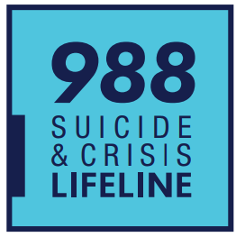

If you or someone you know needs support now,  
**call or text 988 or chat 988lifeline.org**

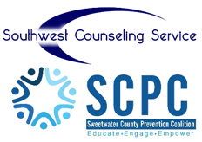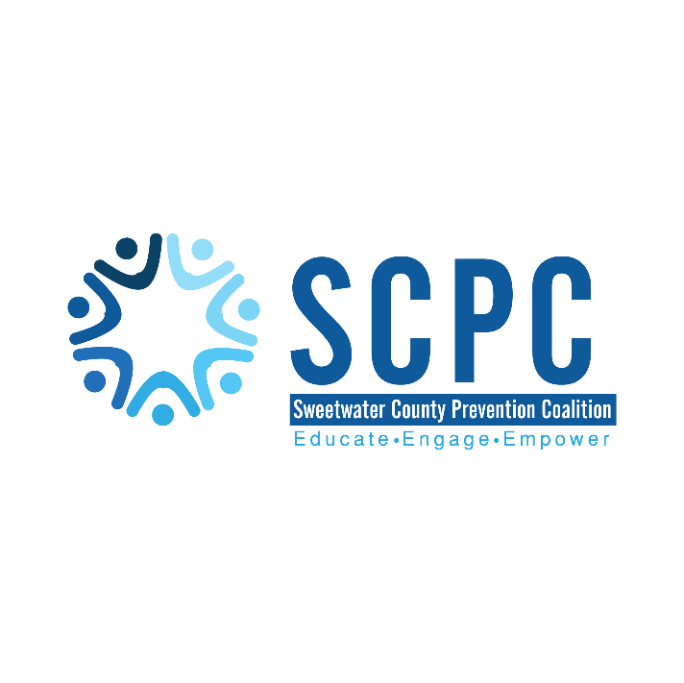

Our Mission: “Sweetwater County Prevention Coalition is committed to the enhancement of community safety and health with a primary focus on substance use and suicide prevention for Sweetwater County Residents.”

Our Vision: “Sweetwater County Prevention Coalition wants to educate and empower the community to make positive lifestyle choices.”